[Applied Learning Task 2]: Analytics - Neil Jiang, David Knox

**Specification Publish Date: 2/9/23**  
**Project Date: 1/08/23**

**Question:** What is the most used gaming platform and title in 2022/2023 >>[**WEBSITE**](https://ALT-3-Analysis-8022023-Neil-Jiang.nialjiang.repl.co) <<

Hypothesis  
We believe that the most common platform for online and offline gaming is the PC. This is because they are usually highly customizable and personal, and for some people building computers is a hobby. They typically feature a broader range of adjustable in-game settings to fit the requirements of your computer (graphics). Pc’s can also be used for a variety of different functions, such as browsing the web, checking the news, social media, etc. The Main reasons why console players don’t switch to PCs is because that they are not used to the keyboard and mouse format, or console specific games. However, because of the PCs wide range of features, you can plug in a controller and use it normally in supported games whereas consoles usually don’t support the keyboard and mouse format.

The second closest would be a close tie between consoles and mobile phones. This is because mobile phones are one of the easiest sources to play games. The phone game market dominates the pc and console versions added together. With mobile phones at 52% whilst consoles and PCs are 20% and 28%.

|  |  |  |
| --- | --- | --- |
| **Platform:** | **Pros:** | **Cons:** |
| Computers/PC’s | + More customizable. Wider range of in-game settings to adjust  + Usually more graphically intense. Graphics look better as some computers run faster than consoles  + More fps/performance. Computers are built with performance in mind (with exceptions), whilst consoles are usually built with portability and compactness.  + Wider range of peripherals. Keyboard and mouse, controllers, VR headsets, driving/steering wheel and pedals sets, etc.  + PCs dominate the indie game market. | + Computers are usually not as portable as a console. Laptops are an exception, however usually the price to performance ratio defers users.  + PCs are usually quite expensive with the entry level usually between 500-1000 euros  + Graphics cards are still expensive due to the market in 2020, however prices are dropping. |

|  |  |  |
| --- | --- | --- |
| Consoles Xbox, PlayStation, Nintendo Switch | + Ease of use. The main point of consoles is that they are more user friendly. They are designed to play games, usually a plug and play type.  + A lot of console exclusive games such as Demon souls, early versions of DMC, God of War Ragnarök, etc. Some titles do get a computer port but usually it's when the hype dies down, pc ports are known for being a worse overall experience (Nier Automata). | + Lower range of peripherals,  + Often can only be used for gaming or light browsing such as Netflix and YouTube  + Peripherals such as controllers are expensive with third part controllers being nearly unusable compared to the PC counterparts |
| Mobile Phone | + One of the portable platforms for gaming, take it anywhere and boot up any game you want + They also dominate the gaming market, sharing 52%. | + Most games on mobile phones are usually badly designed with microtransactions and ads  + Notorious for clickbait ads  + Performance is often lower than consoles and PCs. (No cyberpunk 2077) |

Method:  
To gather the dataset, Microsoft forms will be used. People will be surveyed on the specific platform they use, (pc, console, mobile) and the respective device within (Windows 11, Xbox, PlayStation). In the past, I conducted a similar survey and will also use those results.  
 Ethical Issues:  
Every survey and dataset were gathered anonymously. Names and Dates are not kept or stored in any location.

Results/Data:

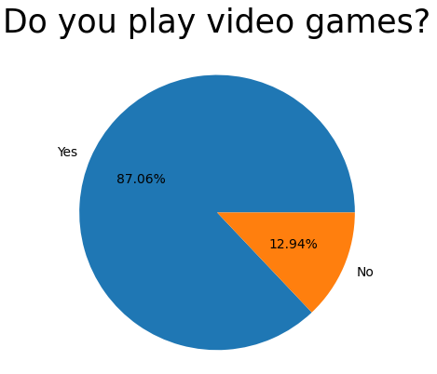

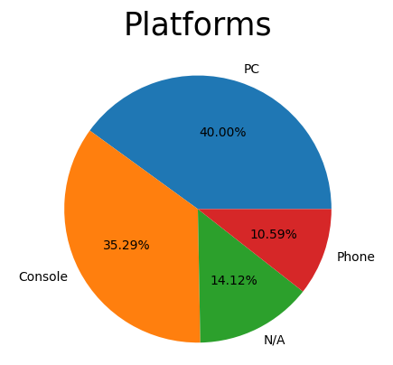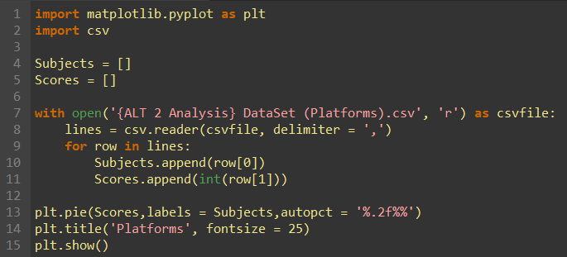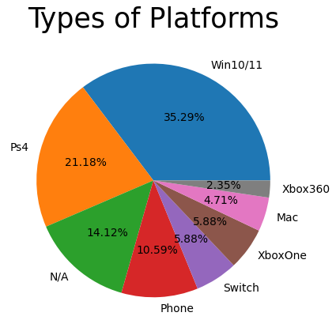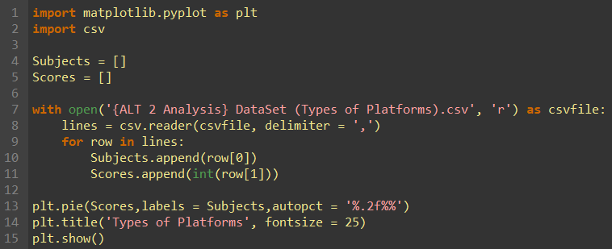

Conclusion/Reflection:  
To conclude this project, my hypothesis was half correct. PC players won over console players, however mobile phones were not as close as I expected.

I believe this is because of 2 major issues.  
 1.) A wider range of people were needed.. Surveys will need to be gathered from a wider range of ages and locations. Events and the time of year should also be accounted for, such as the release of new games, bugs in games, etc.  
 2.) Limited number of options in survey. My survey was very limited in the number of options the person could choose. For example, most people play on many different platforms. For example, people may play on both consoles and computers, however my survey only allowed one to be chosen.